Automobile Ownership
Student’s Name
Institution Affiliation

Automobile Ownership
Buying a car
Challenge: Select a car to purchase. Payment for the car will be through a down payment. Analysis will be made based on changing the amount of down payments. How will the graph change based on your knowledge of slope and y-intercept.
- Read the article “Top Five Biggest Mistakes when buying a car”. List and bliefly describe in your own words the five biggest mistake consumers make when buying cars.
Solution
- Choosing the wrong vehicle
It is advisable to buy a car that meets one specific goal. Before buying a car, it is important to specify the objectives. Of one is single, is of no important to buy an eight sitter car.
- Not taking into consideration of other costs
Most people when buying cars only consider the actual marked price of the car not remembering all the other hidden long-term maintenance and insurance costs that go along with the vehicle. Insurance premium increases with the value of the car. The move valuable the car is, the more you pay.
- Thinking in terms of monthly payments
Most people who want to buy a car are not able to pay the cash once. They pay in monthly bases. The negotiation revolves around hoe much per month not remembering that focusing on the on how much more the consumer pays when compared with marked price. The dealers always adjust their interest and so any vehicle can fit the customers’ budget.
- Buying new verses old car
Vehicles depreciate in value very fast, meaning that when one buys a new car, it will continuously decrease its value from the moment one takes the ownership. At time its advisable to buy a one year or two old since the original owner take the 40% of the depreciation. Currently car do not have warrant, there is no advantage of buying a new car over a slightly used car.
- Putting $0
One can be able to buy a new car with no money down. But it’s good to remember that vehicle depreciates at very high speed, and hence it means that one always have a big loan than exactly the value of the car. If you do not pay out down payment, taxes and other fees are enrolled to the loan.
- True (T) or False (F)
F 1. It is smart to buy a car for $0 down (false)
F 2. When considering a vehicle, the cost of the car is the only financial consideration
F 3. A new car is a wiser investment financially than a 2 year old (false)
- Use the internet to describe the following terms
- Down payment
This is the initial amount of money that a person pays at the time he or she buys something on credit
- Monthly payment
This is the amount a borrower is required to pay each month until the debt is paid off. Monthly payments is specified in loan documents and are calculated when due.
- Life of the loan
The term life-of-loan is the term to determine the time you take to pay the loan before the loan is trucked
- Y-intercept
In a graph of a straight line, y-intercept is point where the line cuts the vertically y-axis.
- Slope
This is steepness of the line in a graph. It is given by the ratio of change y-axis to the change in x-axis
- Search the internet for the car you would purchase. Keep in mind that you should be reasonable with your desires. You can “dream” later on the activity.
Describe in detail your vehicle and cost.
I would like to purchase the 2018 Nissan Sentra S with manual transmission.
Manufactured suggested retail price is about $18000
- “Just the facts” write a journal entry when this data is completed.
- Cost of vehicle = $18000
- Down payment (10%) = $1800
- Balance borrowed = $16200
- Monthly payment = $337.50
- Graph the data from the chart
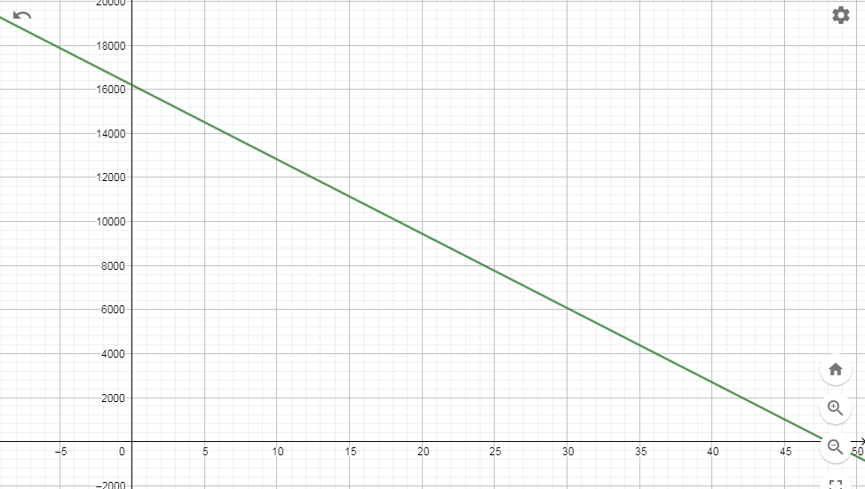
X-axis-number of months
Y-axis- balance owned

Numbers of months | Balance owned (balance borrowed-number of months *monthly)
0 | $16200
1 | $15862.5
2 | $15525.0
3 | $15187.5
4 | $14850.0
20 | $9450.0
40 | $2700
45 | $1012.5
46 | $675
47 | $337.5
48 | 0

- Describe the shape of the graph(say more than it is a straight line)
The graph of balance owned on y-axis versus number of months on x-axis is a straight line from left to write implying that it has a negative gradient and it touches both the axis.
- If time in months is the independent
Then balance owned in dollars is dependent variable
- Write an equation (in the slope-intercept form y=mx+b) to represents the situation of buying a car as described in this problem. (hint look at the graph or table to determine the slope and y-intercept
Solution
Gradient = change in y/change in x
Taking two points, (0, 16200), (48, 0)
Slope = (0-16200)/ (48-0) =-337.5
Taking an arbitrary point (x,y) and (0,16200)
(y-16200)/(x-0) = -337.5
Simplify, y = -337.5 + 16200
M=-337.5 slope
Y= 16200 y-intercept
- What does the y-intercept represent?
Balance borrowed
- What is the slope in the context of this problem
Slope represents monthly payment
- Is the slope positive or negative? Explain in the context of this problem.
Slope is negative. The slope is negative indicating that the balance owned is reducing to zero as time increases.
- What does the x-intercept represent in the context of this problem?
x- Intercept represents life-of-lone
- If the graph translated 3 units up,
Is the monthly payment or the down payment being changed? Down payment is the one being changed
How does that change the graph and how does that change the outcome of this problem?
Y-intercept becomes $19200, while x-axis 57 months. The gradient did not change. This implies that the time for payment increases as balance owned has increased.
Graph the new graph with the original graph in your calculator. Describe what happens to the graph.
The graph moves three units
What type of transition is this? What is the new equation for this new line (translated three units up)?
Vertical shift
- Sketch the graph as it now appear

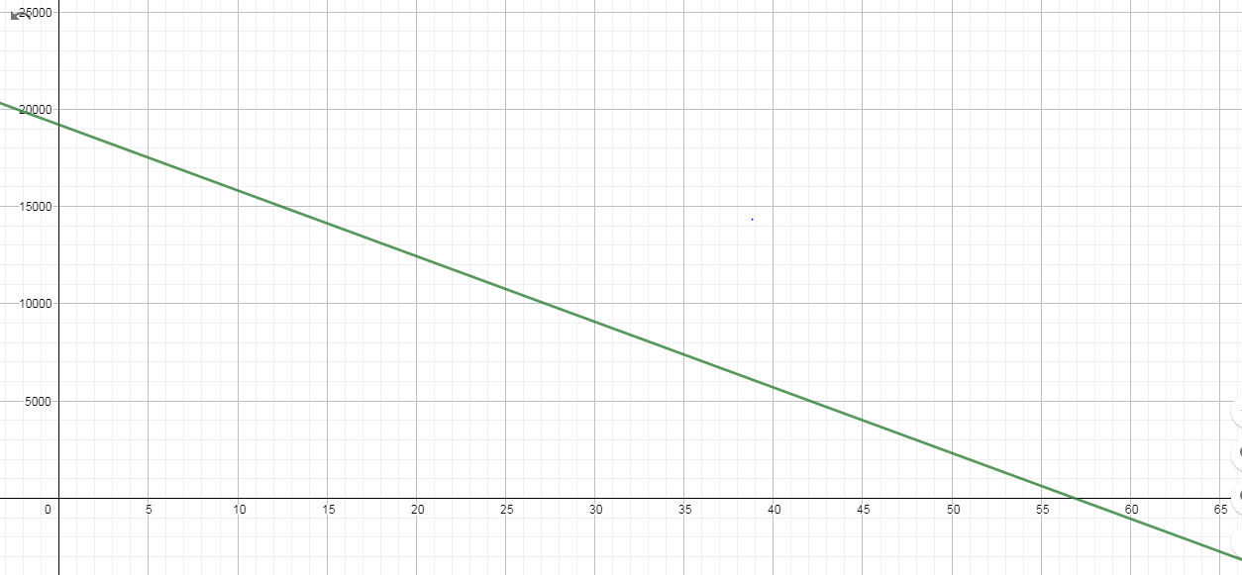
X-axis =number of months
Y-axis- balance owned
- If the slope on original graph is doubled, what happened to the monthly payment and /or the down payment? Monthly payment also doubles
That type of transformation will represent this change? Horizontal starching
Write the equation for new graph.
Y=-2mx +16200
Y=-675x+16200
What stays the same and what changes from the original equation?
Down payment changes
Balance owned remain the same
What is the effect on the outcome of the life of the loan?
The life-of-lone is halved to 24 months
- If the slope of the original graph is cut by 25%, does the monthly payment or the down payment change? Monthly payment is reduced by 25% to $253.125
Transferring is the effect on the outcome of the life of the loan?
The life-of-lone increases to 64 months

